SS 1 Dm 1 nn-1

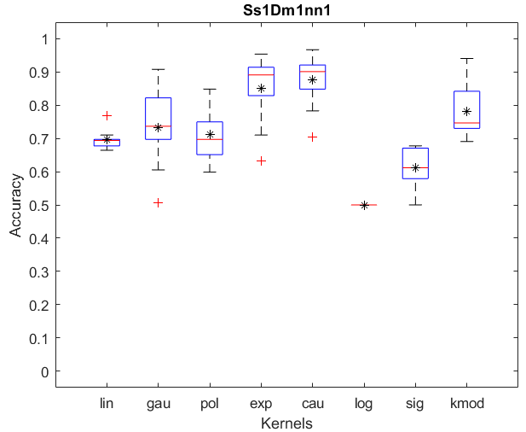

SS 1 Dm 1 nn-k

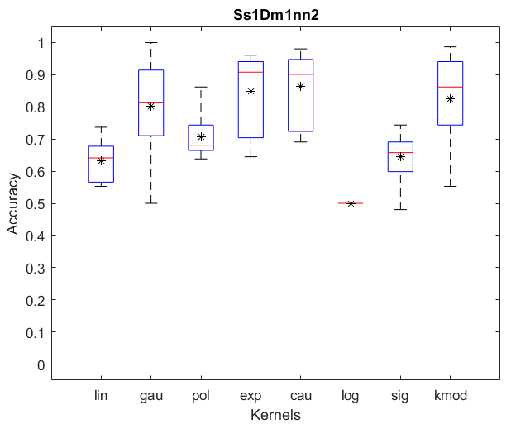

SS 1 Dm 2 nn-1

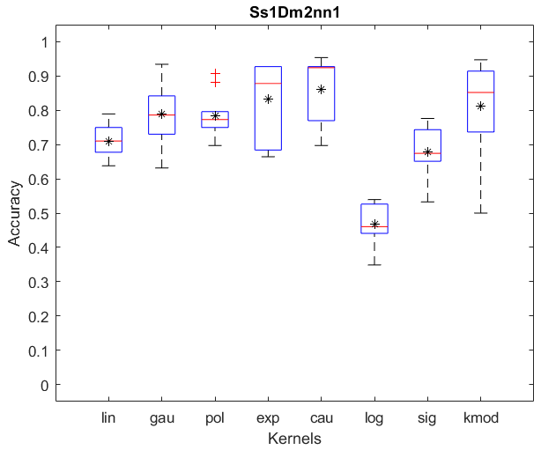

SS 1 Dm 2 nn-k

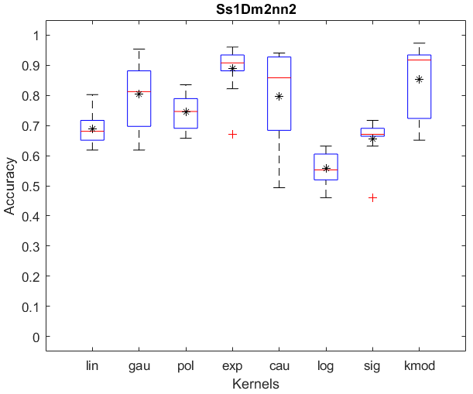

SS 2 Dm 1 nn-1

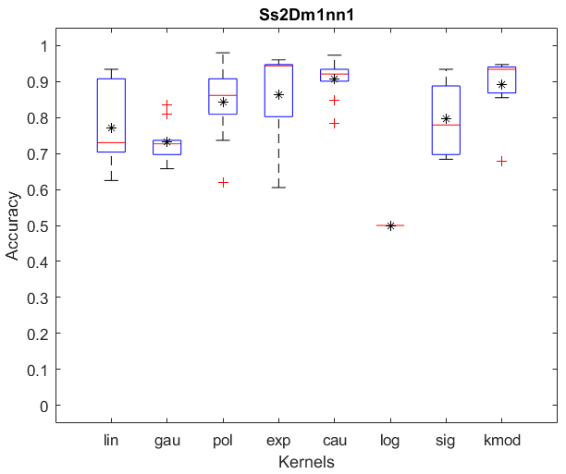

SS 2 Dm 1 nn-k

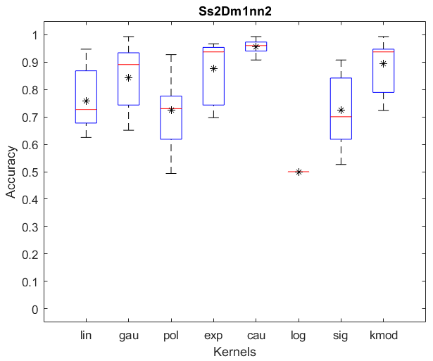

SS 2 Dm 2 nn-1

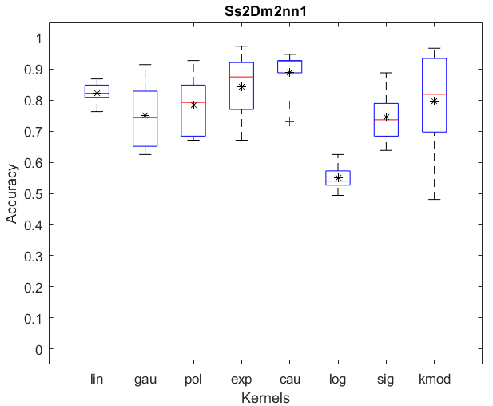

SS 2 Dm 2 nn-k

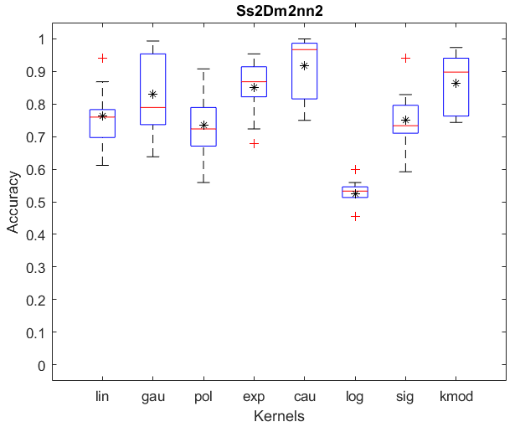

SS 3 Dm 1 nn-1

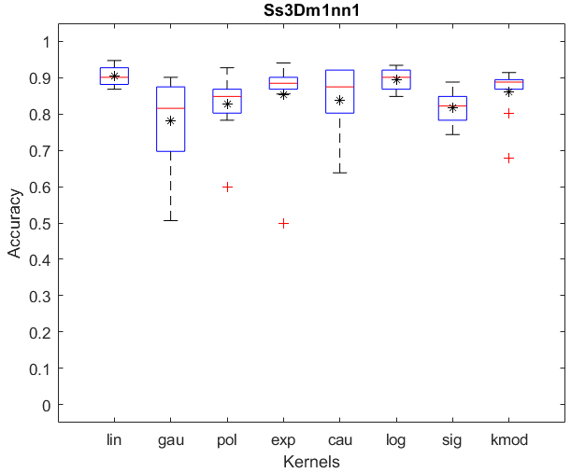

SS 3 Dm 1 nn-k

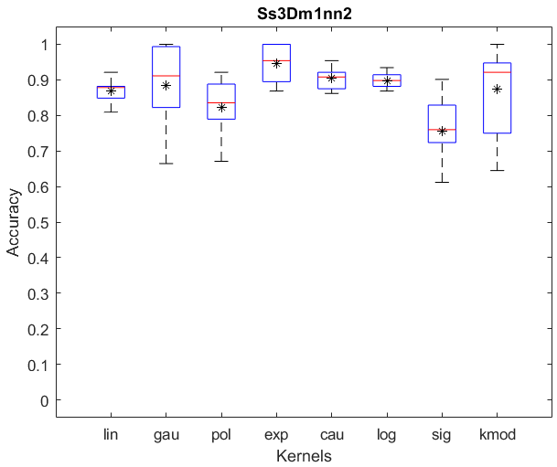

SS 3 Dm 2 nn-1

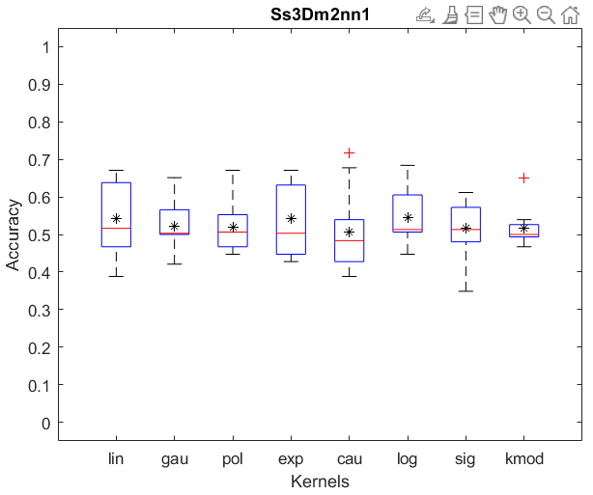

SS 3 Dm 2 nn-k

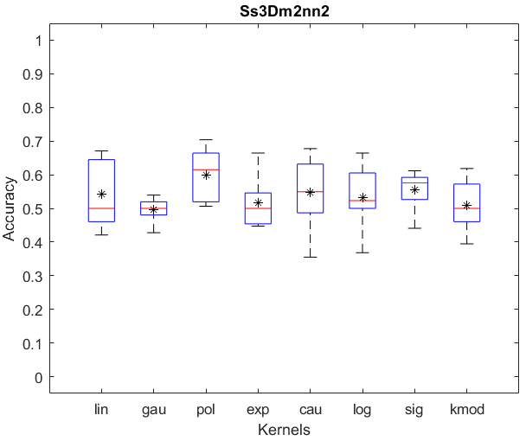

SS 4 Dm 1 nn-1

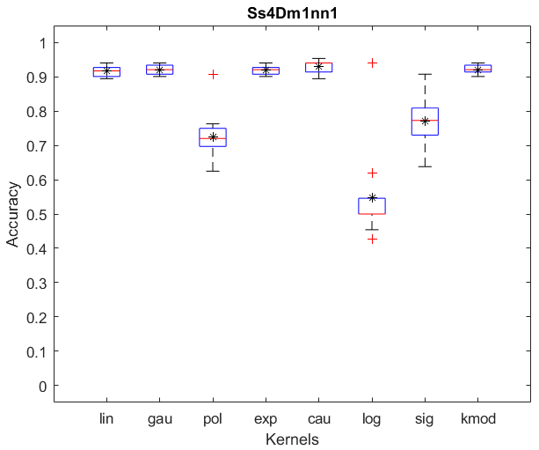

SS 4 Dm 1 nn-k

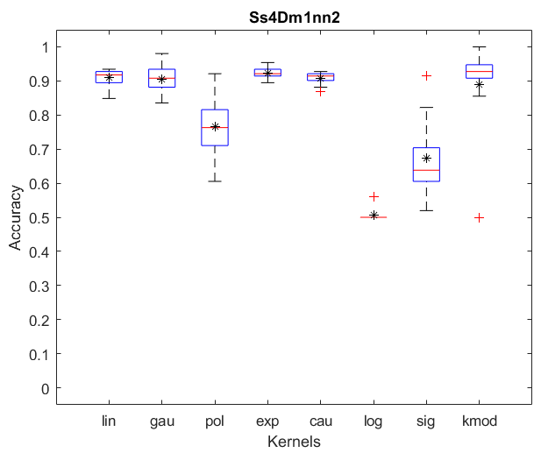

SS 4 Dm 2 nn-1

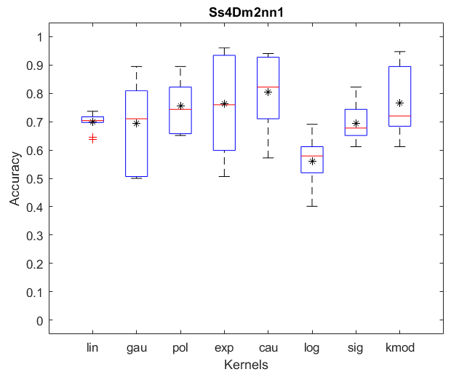

SS 4 Dm 2 nn-k

